Problem:03 Do the following to write program for a Single Linked List:
Create a singly linked list by inserting node one by one at the end.
Display your list.
Insert a new item at a specific position (at the beginning and after a given node)
Search an item into your linked list.
Delete an item from the list (at beginning, at last and at middle)
#include <iostream>
using namespace std;
struct Node {
int data;
Node* next;
};

Node *fptr, *tptr, *pptr, *nptr;
void createList() {
fptr = tptr = NULL;
int n, item;
cin >> n;
for(int i = 0; i < n; i++) {
cout << "Enter node value " << i+1 << ": ";
cin >> item;

nptr = new Node;
nptr->data = item;
nptr->next = NULL;

if(fptr == NULL) {
fptr = tptr = nptr;
} else {
tptr->next = nptr;
tptr = nptr;
}
}
}

void displayList() {
tptr = fptr;
while(tptr != NULL) {
cout << tptr->data << " -> ";
tptr = tptr->next;
}
cout << "NULL" << endl;
}
void insertAtBeginning(int value) {
nptr = new Node;
nptr->data = value;
nptr->next = fptr;
fptr = nptr;
}
void insertAfterNode(int afterValue, int newValue) {
tptr = fptr;
while(tptr != NULL && tptr->data != afterValue)
tptr = tptr->next;

if(tptr != NULL) {
nptr = new Node;
nptr->data = newValue;
nptr->next = tptr->next;
tptr->next = nptr;
} else {
cout << afterValue << "not found in the list"<<endl;
}
}

bool searchItem(int value) {
tptr = fptr;
while(tptr != NULL) {
if(tptr->data == value)
return true;
tptr = tptr->next;
}
return false;
}
void deleteAtBeginning() {
if(fptr == NULL) return;
tptr = fptr;
fptr = fptr->next;
delete tptr;
}
void deleteAtEnd() {
if(fptr == NULL) return;
tptr = fptr;
if(fptr->next == NULL) {
delete fptr;
fptr = NULL;
return;
}
while(tptr->next != NULL) {
pptr = tptr;
tptr = tptr->next;
}
pptr->next = NULL;
delete tptr;
}

void deleteMiddle(int delValue) {
tptr = fptr;
while(tptr != NULL && tptr->data != delValue) {
pptr = tptr;
tptr = tptr->next;
}
if(tptr == NULL) {
cout << delValue << "not found the list"<<endl;
return;
}
pptr->next = tptr->next;
delete tptr;
}

int main() {
createList();
cout << "enter Linked list: ";
displayList();
int value;
cout << "Insert at beginning: ";
cin >> value;
insertAtBeginning(value);
cout << "insert a node at beginning: ";
displayList();

int afterVal, newVal;
cout << "After node value insert: ";
cin >> afterVal;
cout << "After new value insert: ";
cin >> newVal;
insertAfterNode(afterVal, newVal);
cout << "After insert " << afterVal << ": ";
displayList();

cout << "Enter value to search : "<<endl;
cin >> value;
if(searchItem(value))
cout << value << "found in the list"<<endl;
else
cout << value << "not found"<<endl;

deleteAtBeginning();
cout << "Delete at beginning: ";
displayList();
deleteAtEnd();
cout << "Delete at last value: ";
displayList();
cout << "Enter value to delete from middle: ";
cin >> value;
deleteMiddle(value);
cout << "Delete " << value << " from middle: ";
displayList();
}
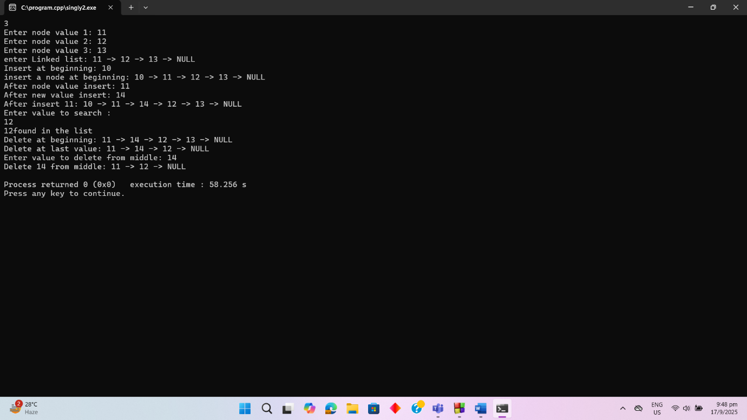

Problem:04 Write a C++ code to implement Doubly Linked List operations
2.Implement Stack using Linked List
3.Implement Queue using Linked List
4.Implement a program to sort the elements in a Linked List

#include <iostream>
using namespace std;

struct Node {
int data;
Node* prev;
Node* next;
};

Node *fptr = NULL, *tptr = NULL, *nptr = NULL;

void createDoublyList() {
fptr = tptr = NULL;
int n, item;
cin >> n;

for(int i = 0; i < n; i++) {
cout << "Enter node value " << ": ";
cin >> item;

nptr = new Node;
nptr->data = item;
nptr->prev = nptr->next = NULL;

if(fptr == NULL) {
fptr = tptr = nptr;
} else {
tptr->next = nptr;
nptr->prev = tptr;
tptr = nptr;
}
}
}

void displayDoublyList() {
Node* temp = fptr;
while(temp != NULL) {
cout << temp->data << " <-> ";
temp = temp->next;
}
cout << "NULL" << endl;
}

void insertBeginning(int value) {
nptr = new Node;
nptr->data = value;
nptr->prev = NULL;
nptr->next = fptr;
if(fptr != NULL) {
fptr->prev = nptr;
}
fptr = nptr;
}

void insertEnd(int value) {
nptr = new Node;
nptr->data = value;
nptr->next = NULL;

if(fptr == NULL) {
nptr->prev = NULL;
fptr = nptr;
return;
}

Node* temp = fptr;
while(temp->next != NULL){
temp = temp->next;
}
temp->next = nptr;
nptr->prev = temp;
}
void insertAfter(int key, int value) {
Node* temp = fptr;
while(temp != NULL && temp->data != key) {
temp = temp->next;
}
if(temp == NULL) {
cout << "Node " << key << " not found" << endl;
return;
}
nptr = new Node;
nptr->data = value;
nptr->next = temp->next;
nptr->prev = temp;
if(temp->next != NULL) {
temp->next->prev = nptr;
}
temp->next = nptr;
}

void deleteBeginning() {
if(fptr == NULL) return;
Node* temp = fptr;
fptr = fptr->next;
if(fptr != NULL) {
fptr->prev = NULL;
}
delete temp;
}

void deleteEnd() {
if(fptr == NULL) return;
Node* temp = fptr;
while(temp->next != NULL) temp = temp->next;
if(temp->prev != NULL) {
temp->prev->next = NULL;
} else {
fptr = NULL;
}
delete temp;
}

void deleteValue(int key) {
Node* temp = fptr;
while(temp != NULL && temp->data != key)
temp = temp->next;
if(temp == NULL) {
cout << "Value " << key << " not found" << endl;
return;
}
if(temp->prev != NULL)
temp->prev->next = temp->next;
else
fptr = temp->next;
if(temp->next != NULL)
temp->next->prev = temp->prev;
delete temp;
}

bool search(int key) {
Node* temp = fptr;
while(temp != NULL) {
if(temp->data == key)
return true;
temp = temp->next;
}
return false;
}

Node *top = NULL;

void push(int value) {
nptr = new Node;
nptr->data = value;
nptr->next = top;
top = nptr;
}

void pop() {
if(top == NULL) return;
tptr = top;
top = top->next;
delete tptr;
}

void displayStack() {
tptr = top;
while(tptr != NULL) {
cout << tptr->data << " -> ";
tptr = tptr->next;
}
cout << "NULL" << endl;
}

Node *front = NULL, *rear = NULL;

void enqueue(int value) {
nptr = new Node;
nptr->data = value;
nptr->next = NULL;
if(front == NULL) front = rear = nptr;
else {
rear->next = nptr;
rear = nptr;
}
}

void dequeue() {
if(front == NULL) return;
tptr = front;
front = front->next;
delete tptr;
}

void displayQueue() {
tptr = front;
while(tptr != NULL) {
cout << tptr->data << " -> ";
tptr = tptr->next;
}
cout << "NULL" << endl;
}

void sortList(Node* fptr) {
Node *i, *j;
for(i=fptr; i!=NULL; i=i->next) {
for(j=i->next; j!=NULL; j=j->next) {
if(i->data > j->data) {
int temp = i->data;
i->data = j->data;
j->data = temp;
}
}
}
}

void displayList(Node* fptr) {
tptr = fptr;
while(tptr != NULL) {
cout << tptr->data << " -> ";
tptr = tptr->next;
}
cout << "NULL" << endl;
}

int main() {
createDoublyList();
cout << "Doubly Linked List: ";
displayDoublyList();

int val1, val2, key;
cout << "Enter value to insert at beginning: ";
cin >> val1;
insertBeginning(val1);
displayDoublyList();

cout << "Enter value to insert at end: ";
cin >> val2;
insertEnd(val2);
displayDoublyList();

cout << "Enter key after which to insert: ";
cin >> key;
cout << "Enter value to insert after " << key << ": ";
cin >> val1;
insertAfter(key, val1);
displayDoublyList();

cout << "Delete first node" << endl;
deleteBeginning();
displayDoublyList();

cout << "Delete last node" << endl;
deleteEnd();
displayDoublyList();

cout << "Enter value to delete: ";
cin >> val1;
deleteValue(val1);
displayDoublyList();

cout << "Enter value to search: ";
cin >> val1;
if(search(val1))
cout << val1 << " found the list" << endl;
else
cout << val1 << " not found" << endl;

top = NULL;
int stack1, value1;
cout << " push element into Stack " << endl;
cin >> stack1;
for(int i=0; i<stack1; i++) {
cout << "Enter value to push: ";
cin >> value1;
push(value1);
}
cout << "Stack: ";
displayStack();
pop();
cout << " pop: ";
displayStack();

front = rear = NULL;
int queue1, value2;
cout << " enque element " << endl;
cin >> queue1;
for(int i=0; i<queue1; i++) {
cout << "Enter value to enqueue: ";
cin >> value2;
enqueue(value2);
}
cout << "Queue: ";
displayQueue();
dequeue();
cout << "dequeue: ";
displayQueue();

fptr = tptr = NULL;
int s1, val3;
cout << " sorting list";
cin >> s1;
for(int i=0; i<s1; i++) {
cout << "Enter value for node " << " ";
cin >> val3;
nptr = new Node;
nptr->data = val3;
nptr->next = NULL;
if(fptr == NULL)
fptr = tptr = nptr;
else {
tptr->next = nptr;
tptr = nptr;
}
}
cout << " List for Sorting: ";
displayList(fptr);
sortList(fptr);
cout << "Sorted List : ";
displayList(fptr);
}
